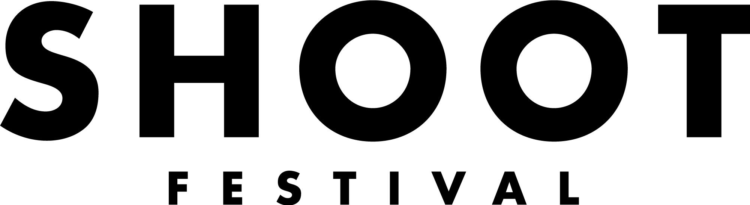

Dear Applicant,

Thank you for submitting your application for Shoot Festival 2022.

This project is supported by Arts Council England and we need to ask you for a little information about yourself. This information is collected separately from the applications and won’t be cross-referenced in any way.

Please highlight or delete accordingly.

1. Gender: Male • Female • I prefer to use my own term (Please identify the term you wish to use) • Prefer not to say

2. Sexual Orientation: Bisexual • Gay • Lesbian • Heterosexual • I prefer to use my own term (Please identify the term you wish to use) • Prefer not to say

3. Age: 0-19 • 20-34 • 35-49 • 50-64 • 65+ • Prefer not to say
4. How would you describe your national identity?
English • Welsh • Scottish • Northern Irish • British • Other (Please identify) • Prefer not to say
5. Please describe your ethnic origin by choosing the most appropriate description from the sections below

Asian Bangladeshi • Asian Indian • Asian Pakistani • Asian - Chinese • Any other Asian background

Black African • Black Caribbean • Any other other Black background

White: English • Scottish • Welsh • Northern Irish • Irish • Gipsy or Irish Traveller • Any other White background

Mixed/multiple ethnic groups: White and Black Caribbean • White and Black African •
White and Asian • Any other mixed background •
Other ethnic group (Please identify) • Prefer not say
6. Do you consider yourself to be D/deaf, disabled, living with autism or a long term condition?
Yes • No • Prefer not to say

Thank you for completing this form. Please email to shootfestival@gmail.com along with your application

