If you need any of this information in a different format or would like to suggest a different form of application please contact our General Manager, Laura Killeen at laura.killeen@coventryshootfestival.com

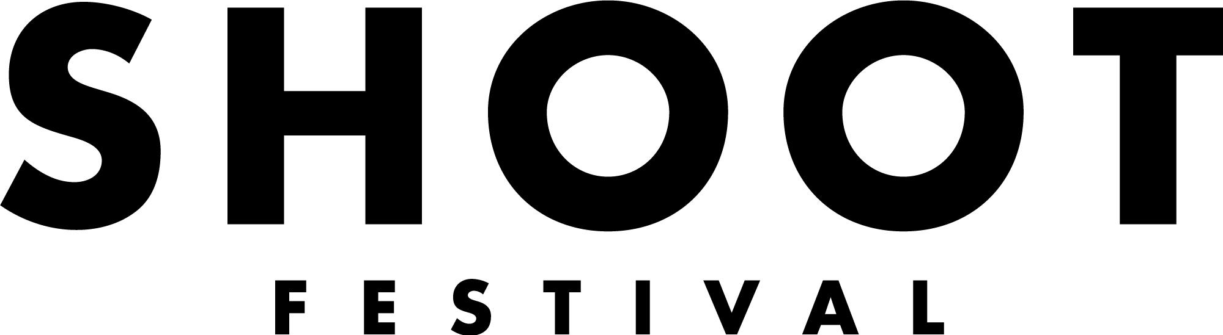

A diverse festival platforming the best of Coventry and Warwickshire’s up and coming talent across a range of artforms.

THE SOUND STAGE
The Sound Stage is a day long event featuring nine emerging and early career musicians, ensembles and bands from any genre.

It is exclusively committed to work being developed in Coventry and Warwickshire and is a great opportunity to showcase your work and build connections with local and established organisations and artists.

We are looking to programme a diverse range of original music of any genre celebrating the best of Coventry and Warwickshire’s talent. The Sound Stage will take place on a specially constructed stage at the Bull Yard in Coventry city centre alongside our Performance Programme, Workshops, and Visual Arts Programme.

WHAT WE CAN OFFER YOU
- A £125 fee for each act
- The chance to win our Artist Development Award worth £1000 (£500 in cash and £500 in mentorship/development, bespokely designed for you) This will be awarded to the act our industry judges feel has the most potential to be developed further
- The opportunity to perform your original work on our professional stage at the Bull Yard on Saturday 23rd April 2022
- Full technical support and set up in partnership with The Tin Music and Arts
- A basic band set up will be provided - let us know if your act needs a more ambitious set up and we will aim to provide
- Photography and filming of your performance
- The chance to perform your work at Coventry and Warwickshire’s most exciting new festival in front of an audience made up of local people, industry professionals and fellow artists
- The chance to meet other emerging artists who are also making work locally

WHAT ARE WE LOOKING FOR?
- Original work whether that is self written material or radical transformations of existing music
- We create a diverse and unique programme and accept applications from all music genres
- All artists/companies must live, work, or study in the CV postcode which covers the following areas: Coventry, Kenilworth, Rugby, Leamington Spa, Warwick, Nuneaton, Bedworth, Atherstone, Stratford Upon Avon, Shipston on Stour and Southam
- Artists must be aged 18+

EMERGING ARTIST?
We use the term ‘emerging artist’ very broadly, whether you consider yourself a well-seasoned professional looking for more local opportunities or perhaps this is your very first performance, we welcome all artists who feel like they might be able to benefit from this opportunity to apply.

OUR SELECTION CRITERIA
Final selection will be decided by the Festival Directors. Applications will be judged against the selection criteria listed below:

1. Artistic merit of proposed ideas and clarity of proposal
2. The performance must be considered the artist’s/band’s own original work. This can include covers but they must be interpretations of pre-existing material rather than a direct copy
3. All artists/companies must live, work, or study in the CV postcode which covers the following areas: Coventry, Kenilworth, Rugby, Leamington Spa, Warwick, Nuneaton, Bedworth, Atherstone, Stratford Upon Avon, Shipston on Stour and Southam
4. We are looking to programme a diverse range of music genres and styles
5. Suitability to our audiences
6. The work must be achievable with the resources that The Tin and Shoot Festival can provide and suitable for our outdoor stage - the performing area will be covered
7. Artists should take into consideration that the venue is not a traditional gig venue and we expect to see an awareness of this in applications
8. Artists must be aged 18+
9. Artists must conform with statutory and local authority rules concerning health and safety, obscenity and defamation. It should be noted that this is a public space so we ask to acts to be conscious of this when they perform

You must be available to:
- Attend a production meeting during the lead up to the festival, date TBC
- Attend a sound check on the day of the performance
- Perform at the Sound Stage in the Bull Yard on Saturday 23rd April 2022

Any further questions please contact: shootfestival@gmail.com

THE VENUE: THE BULL YARD
The Sound Stage will take place in the Bull Yard. We will be creating a bespoke, outdoor, enclosed and covered performance area with a raised stage.
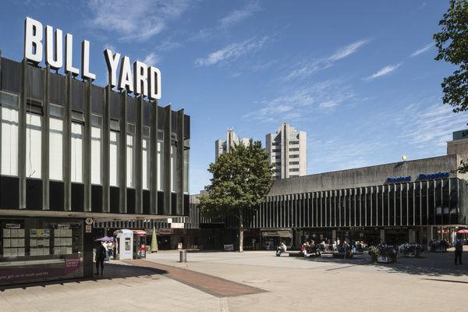

TECHNICAL: BAND SET UP
In partnership with the Tin we will provide a simple band set up for the Sound Stage. This will include:
• Microphones
• PA system and speakers
• Drum Kit
• Guitar Amps
• The stage will be covered and the space will be designed by Vortex Creates

This is our basic technical set-up, if you wish to bring in your own equipment please indicate this in your application. A technician will assist you in your sound check and your performance on Saturday 23rd April 2022.

HOW TO APPLY
Deadline for applications is Friday 14th January 2022 at 10am.

Please send your completed application form, Equal Opportunities and Monitoring form and at least one example track of your work via email to shootfestival@gmail.com with the subject line ‘Application: Sound Stage 2022’.

Although we appreciate that not all artists will have a website or online content, if you do have any additional resources such as press coverage or video footage please send us links or attachments along with your application.

If you would like this application form in an alternative format please contact Laura Killeen, General Manager at shootfestival@gmail.com

You can submit an application by video or audio of no more than five minutes in length. We’re happy to discuss your application with you before you apply.

Good luck!

