If you need any of this information in a different format or would like to suggest a different form of application please contact our General Manager, Laura Killeen at laura.killeen@coventryshootfestival.com

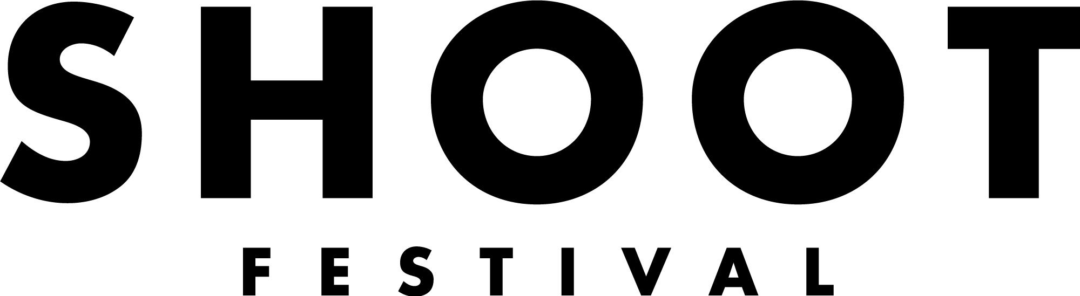

A diverse festival platforming the best of Coventry and Warwickshire’s up and coming talent across a range of artforms.

THE EXHIBITION
The Exhibition will run for two weeks featuring nine emerging visual artists* from all areas of the visual arts.

It is exclusively committed to work being developed in Coventry and Warwickshire and is a great opportunity to showcase your work and build connections with local and established organisations and artists.

We are looking to programme a diverse range of visual artists celebrating the best of Coventry and Warwickshire’s talent. The Exhibition will take place at a venue in Coventry city centre in partnership with Coventry Artspace alongside our Performance Programme, Workshops, and Sound Stage.

*artist = individual artists or up to 3 artists working collaboratively

WHAT WE CAN OFFER YOU
- A £125 fee for each artist selected
- ​​The chance to win our Artist Development Award worth £1000 (£500 in cash and £500 in mentorship/development, bespokely designed for you) This will be awarded to the act our industry judges feel has the most potential to be developed further
- A two week presentation of your work as part of a group exhibition in a city centre venue, Saturday 23rd April - Saturday 7 May 2022
- Technician support to present and install your work
- Photography of your artwork
- The chance to show your work at Coventry and Warwickshire’s most exciting new festival in front of an audience made up of local people, industry professionals and fellow artists
- Potential opportunities post-festival through the Shoot network
- The chance to meet other emerging artists who are also making work in Coventry and Warwickshire

WHAT ARE WE LOOKING FOR?
- Exciting and original work - we take a broad view of the visual arts
- Work produced by individual artists, or collaboratively by no more than 3 artists
- We create a diverse and unique programme and will accept applications from all visual art forms
- Artists must live, work, or study in the CV postcode which covers the following areas: Coventry, Kenilworth, Rugby, Leamington Spa, Warwick, Nuneaton, Bedworth, Atherstone, Stratford Upon Avon, Shipston on Stour and Southam
- Artists must be aged 18+

EMERGING ARTIST?
We use the term ‘emerging artist’ very broadly. Whether you consider yourself a well-seasoned professional looking for more local opportunities or this is your very first exhibition, we encourage all artists who feel they might be able to benefit from this opportunity to apply.

OUR SELECTION CRITERIA
Final selection will be decided by the Shoot Festival Co-Artistic Directors and representatives from Coventry Artspace. Submissions will be considered against the criteria and conditions listed below:

1. Artistic merit and quality
2. The submission must be considered the artist’s original work and must have been produced within the last 3 years
3. There must be a clear indication of how the opportunity will help the artist or group to progress in their career
4. The final selection selection will seek to reflect diversity and breadth of practice
5. All artists/groups must live, work, or study in the CV postcode which includes covers the following areas: Coventry, Kenilworth, Rugby, Leamington Spa, Warwick, Nuneaton, Bedworth, Atherstone, Stratford Upon Avon, Shipston on Stour and Southam
6. The work must be achievable within Shoot Festival resources
7. The work can take any form including: painting, ceramics, textile art, digital art, moving image, sculpture, performance art, sound art, street art, illustration, installation, or anything in between)
8. Artists must be 18+
9. Artists must conform with statutory and local authority rules concerning health and safety, obscenity and defamation (before the event you will be asked to fulfil a risk assessment form)

You must be available to:
- Attend a pre-festival meeting during the lead up to the festival, date TBC
- Support the installation of your work between Tuesday 19th and Friday 22nd April 2022
- Support the opening of the exhibition on Saturday 23rd April 2022
- Support at least two shifts of invigilation, each lasting three hours during the rest of the exhibition Monday 25th April - Saturday 7th May 2022

Any further questions please contact: shootfestival@gmail.com

THE VENUE
The venue is to be confirmed but will be a city centre venue - we will confirm this as soon as possible in January 2022.

TECHNICAL SET UP
We will have two gallery technicians on hand to support your installation between Tuesday 19th and Friday 22nd April 2022.

We have some equipment available eg projectors, speakers and will discuss equipment needs in more detail with the winning artists to support where we can. Please include details of your technical requirements in your application.

HOW TO APPLY
Deadline for applications is Friday 14th January at 10am.

Please send your completed application form, Equal Opportunities and Monitoring form and up to 7 images of your work or online links to your work via email to shootfestival@gmail.com with the subject line ‘Application: Exhibition 2022’.

If you do have any additional resources such as press coverage or video footage please send us links or attachments along with your application. Please include details of your technical requirements.

If you would like this application form in an alternative format please contact Laura Killeen, General Manager at shootfestival@gmail.com

You can submit an application by video or audio of no more than five minutes in length. We’re happy to discuss your application with you before you apply.

Good luck!
