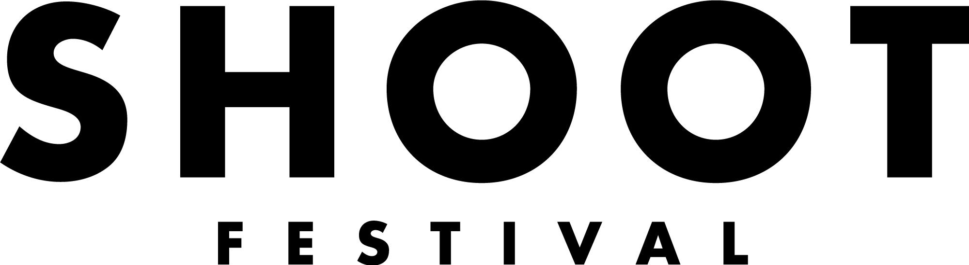
If you need any of this information in a different format or would like to suggest a different form of application please contact our General Manager, Laura Killeen at laura.killeen@coventryshootfestival.com

An Easy Read Call out – The Sound Stage
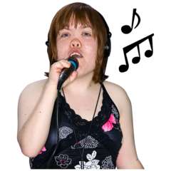  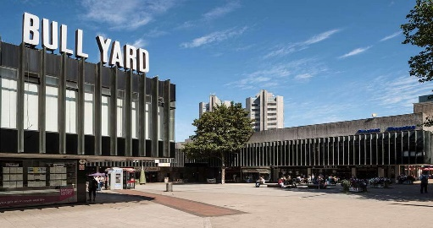 | The Sound Stage is a day long event for nine emerging and early career musicians, ensembles and bands of any genre.  The Sound Stage will take place on a specially made stage at The Bull Yard in Coventry City Centre  We are looking to programme a diverse range of performances celebrating the best of Coventry and Warwickshire talent.
The Sound Stage will happen on Saturday 23rd April 2022. You can perform your original work.

The Festival also includes The Exhibition, The Performance Programme and Workshops.

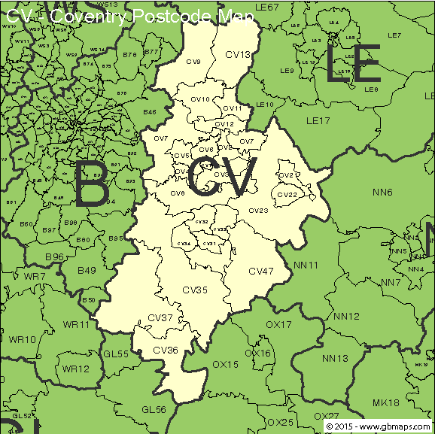  18+  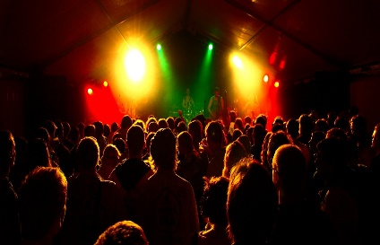  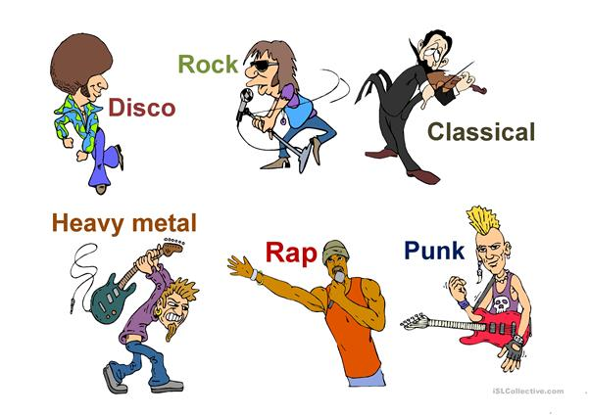 | It is only open to artists that live, work or study in Coventry or Warwickshire – You must have a CV postcode.  You must be aged 18+  An emerging artist is used broadly.  You might be established but want a local connection or this could be your very first performance. We would like anyone who could benefit from this opportunity to apply.  We are looking for:  - Original work whether that is self-written material or radical transformations of existing music  - We create a diverse and unique programme and accept applications from all music genres  The Sound stage will also be BSL interpreted.
What we can offer you
 | £125 fee for every artist chosen
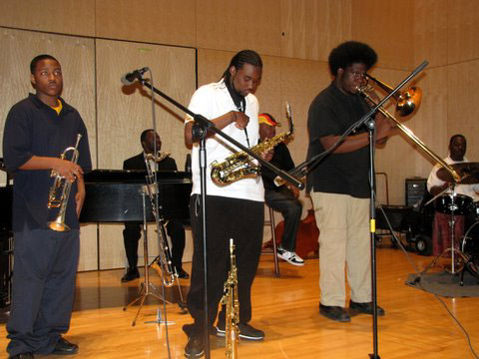 | Opportunity to perform your work in a professional venue in front of an audience made up of local people, Industry professionals and fellow artists.
Help – Full technical support and set up in partnership with
The Tin Music and Arts

A chance to meet other local emerging artists.

 | Photography and filming of your performance.
 | The chance to win our Artist Development Award worth £1000 - £500 to the artist and £500 in mentorship or development.

THE VENUE: THE BULL YARD

The Sound Stage will take place in the Bull Yard.

The stage will be :

- Bespoke

- Outdoor

- Enclosed

- Raised stage

- Covered performance area.

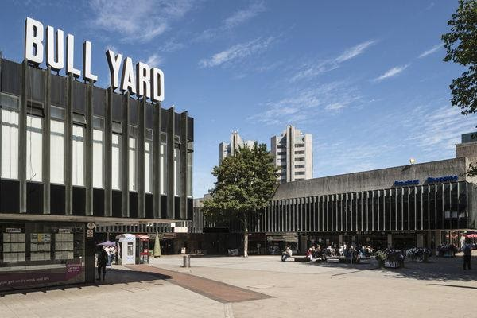
Technical Information - Tech Support we can help with:

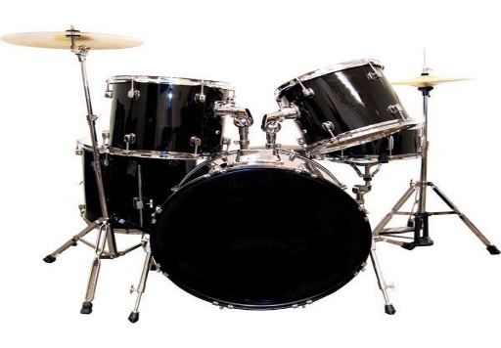 | Drum Kit
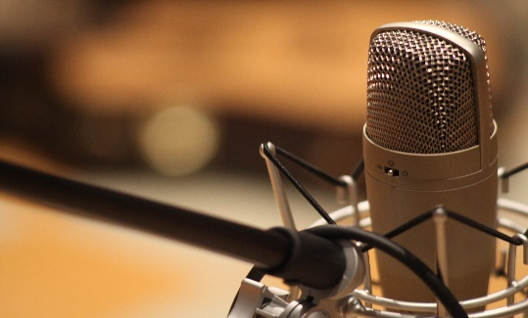 | Microphones
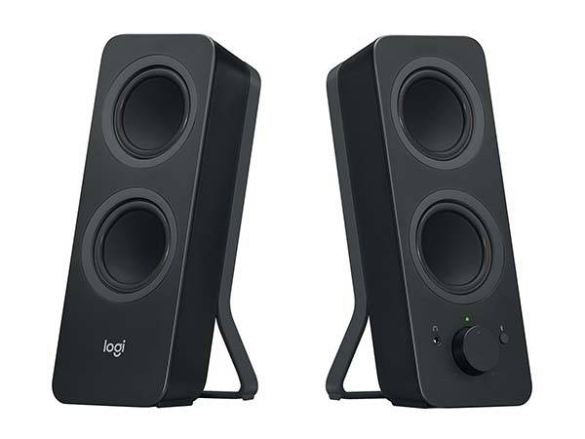 | PA System and Speakers
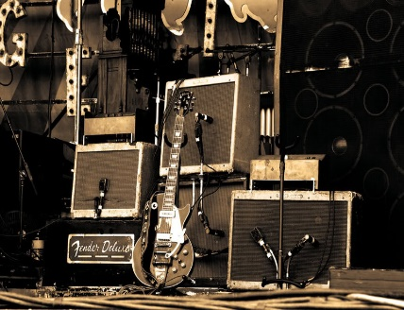 | Guitar Amps

- This is our basic technical set-up. If you wish to bring in your own equipment please tell us in your application.

- A technician will assist you in your sound check and your performance.
Selection Criteria
Final Selection will be decided by the Festival Directors.
Applications will be considered against these:

- What your performance proposal is and the clarity of it.

- It must be your own original work. This can include covers but they must be interpretations of pre-existing material rather than a direct copy.

- We are looking for a diverse range of music and genres.

- The work must be achievable with the resources The Tin and Shoot Festival can provide and suitable for our outdoor staging – the performing area will be covered.

- You must live, work or study within Coventry or Warwickshire.

- Artists should take into consideration that the venue is not a traditional gig venue and we expect to see an awareness of this in applications.

- There will be a risk assessment of the work to make sure it meets Health and Safety and is suitable for diverse audiences in a public space.

How to Apply -
Deadline for applications – Friday 14th January 2022 at 10am

Fill in form – Fill in the form https://www.coventryshootfestival.com/opportunities

or submit video that is no longer than 5 minutes in length,

or apply in an accessible way to meet your needs. If you need help or support applying contact - shootfestival@gmail.com

Check list for application.

- Fill in your personal information
- Answer the questions.
- At least one example of a track of your work.
- Website links if you have them.
- Send links to any additional press coverage or video footage if you have them.
- Fill in and send the Equal opportunities and Monitoring form.
- If you know you have technical requirements let us know.
Email to shootfestival@gmail.com with the subject line Application: Sound Stage 2022

What you will need to do if selected -
Date to be confirmed | Attend a production meeting
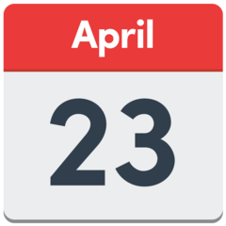 | Attend a sound check on the day of the performance
 | Perform at The Sound Stage in the Bull Yard.

Any questions or access support to complete your application please contact shootfestival@gmail.com

