If you need any of this information in a different format or would like to suggest a different form of application please contact our General Manager, Laura Killeen at laura.killeen@coventryshootfestival.com

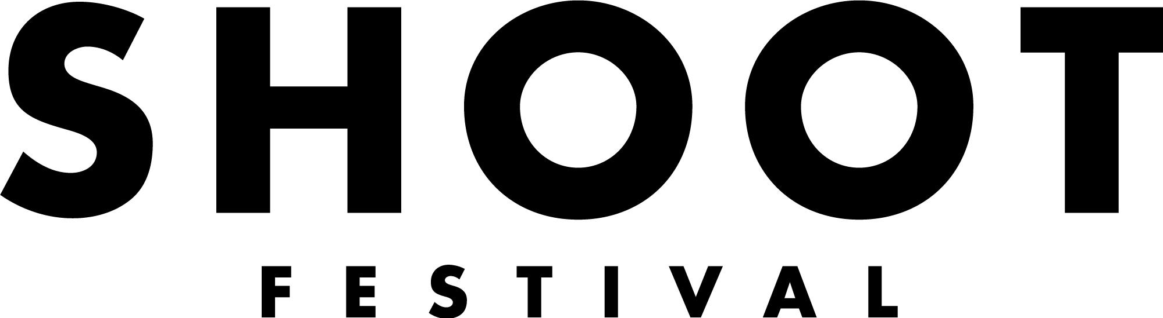

A diverse festival platforming the best of Coventry and Warwickshire’s up and coming talent across a range of artforms.

THE PERFORMANCE PROGRAMME
The Performance Programme is a day long event featuring nine emerging artists and/or companies. It is exclusively committed to work being developed in Coventry and Warwickshire and is a great opportunity to showcase your work and build connections with local and established organisations and artists.

We are looking to programme a diverse range of performances celebrating the best of Coventry and Warwickshire’s talent. The Performance Programme will take place at Theatre Absolute’s Shop Front Theatre alongside our Sound Stage, Workshops, and Visual Arts Programme.

WHAT WE CAN OFFER YOU
- A £125 fee for each act
- The chance to win our Artist Development Award worth £1000 (£500 in cash and £500 in mentorship/development, bespokely designed for you) This will be awarded to the act our industry judges feel has the most potential to be developed further
- The opportunity to perform your work in a professional venue (the Shop Front Theatre) on Saturday 23rd April 2022
- Full technical support including a technical/dress rehearsal and an operator
- Rehearsal space (subject to the venue’s availability)
- Photography and filming of your performance
- The chance to perform your work at Coventry and Warwickshire’s most exciting new festival in front of an audience made up of local people, industry professionals and fellow artists
- Potential opportunities following the festival through the Shoot Festival network
- The chance to meet other emerging artists who are also making work in Coventry and Warwickshire
WHAT ARE WE LOOKING FOR?
- Exciting and original work- this could be new writing, devised work or adaptations of existing material
- We create a diverse and unique programme and accept applications from all live art forms
- All artists/companies must live, work, or study in the CV postcode which covers the following areas: Coventry, Kenilworth, Rugby, Leamington Spa, Warwick, Nuneaton, Bedworth, Atherstone, Stratford Upon Avon, Shipston on Stour and Southam
- Artists must be aged 18+
- We’ll also be asking artists to make their work accessible by using the Difference
Engine and work with a live BSL interpreter in the week leading up to the performance. The Difference Engine is Talking Birds' discreet new tool for making
events and performance accessible to partially-sighted, deaf or hard of hearing
audience members by delivering captioning or audio description direct to their
mobile device. We will be there to support you throughout this process.
For more information about the Difference Engine please go to: https://differenceengine.talkingbirds.co.uk/

EMERGING ARTIST?
We use the term ‘emerging artist’ very broadly, whether you consider yourself a well-seasoned professional looking for more local opportunities or perhaps this is your very first performance, we welcome all artists who feel like they might be able to benefit from this opportunity to apply.

OUR SELECTION CRITERIA
Final selection will be decided by the Festival Directors. Applications will be judged against the selection criteria listed below:

1. Artistic merit of proposed ideas and clarity of proposal
2. The performance must be considered the artist’s original work
3. All artists/companies must live, work, or study in the CV postcode which covers the following areas: Coventry, Kenilworth, Rugby, Leamington Spa, Warwick, Nuneaton, Bedworth, Atherstone, Stratford Upon Avon, Shipston on Stour and Southam
4. The work must be ‘live’ or include ‘live’ elements
5. The work must be achievable in the Shop Front Theatre
6. You should take into consideration that the venue is not a traditional theatre space
7. Special credit will go to applications that use the space in a creative way although this is not essential
8. The work can take any form of live performance including: theatre, dance, solo performance, spoken word, performance poetry or anything in between
9. Artists must be 18+
10. Artists must conform with statutory and local authority rules concerning health and safety, obscenity and defamation (before the event you will be asked to fulfil a risk assessment form)

You must be available to:
- Attend a production meeting during the lead up to the festival (date TBC)
- Attend a technical rehearsal during get-in week Monday 18th - Friday 22nd April 2022
- Perform at the Shop Front theatre on Saturday 23rd April 2022

Any further questions please contact: shootfestival@gmail.com

THE VENUE: THE SHOP FRONT THEATRE
Shoot Festivals’ Performance Programme will be held at Theatre Absolute’s Shop Front Theatre, City Arcade, Coventry. It is the only venue of its kind in the UK, previously being an old fish and chip shop restaurant, once called Fishy Moore’s.

The space is essentially empty, seating approximately 55 people in any configuration of seats that you can imagine. It currently has only domestic voltage, no lighting rig, minimal lighting on stands, nowhere to fly in huge sets and no paint or prop store. It’s not like any regular theatre, but that’s the point. It is very limited in terms of what it offers, but the limitations are what attracted us to the space in the first place.

TECHNICAL SET UP
We are able to provide you with technical equipment but please be aware that as this is a festival held inside a non traditional space, the set-up will be minimal.

Technical support will include:
• Basic lighting set up
• Microphones
• PA system and speakers
• Projection

This is our basic technical set-up, if you wish to bring in your own equipment please indicate this in your application but this must be PAT tested. A technician will assist you in your technical rehearsals and your performance on Saturday 23rd April.

SHOP FRONT THEATRE
The space is adaptable and can be moved to fit any audience position and performance location although please be aware that turnarounds between performances can be as short as 5 minutes - this will be discussed at the production meeting. You can find out more about the space here: http://www.theatreabsolute.co.uk/shop-front-theatre/

HOW TO APPLY
Deadline for applications is Friday 14th January 2022 at 10am.

Please send your completed application form, Equal Opportunities and Monitoring form and three images of your work or images that represent your work to shootfestival@gmail.com with the subject line ‘Application: Performance Programme 2022’.

Although we appreciate that not all artists will have online content, if you do have any additional resources such as press coverage or video footage please send us links or attachments along with your application.

If you would like this application form in an alternative format please contact Laura Killeen, General Manager at shootfestival@gmail.com You can submit an application by video or audio of no more than five minutes in length. We’re happy to discuss your application with you before you apply.

Good luck!

Shop Front Theatre Ground Plan

